Getting satellite images for your terrain

Preliminar work: (don’t do again If you already did it)
1) Create your .geo file (join_geos, for example), process it and save the mesh. Open the mesh with gmsh and check that the non-driveable zone (Physical Surface 222) is part of the mesh.
2) Run trocea_malla (inside s1_mesh)
Now we use SasPlanet to get the images
3) Create the .hlg file:
> cd s1_mesh
> create_hlg

A file called s1_mesh\grid.hlg has been created with the coordinates of a box that comprises your terrain.
4) Open s1_mesh\grid.hlg with SASPlanet:
Operations -> Select -> Load from file -> Load -> Start
5) Save the images in a folder (c:\example_folder) with the desired splitting (5x3 in this example):
Operations -> Select -> Previous Selection -> Stick -> Start (YOU MUST select .dat file bindings)
The satellite images have been splitted and the info about the splitting coordinates is in the created .dat files.
6) Now we can add the grid to joined.geo so we can see the limits of the downloaded images:

> add_dat_to_geo('c:\example_folder')
(if you don’t want to add the grid to joined.geo, just select the option “Create grid.geo” when asked)
7) Open joined.geo and you will see the limits of the downloaded images you have inside c:\example_folder
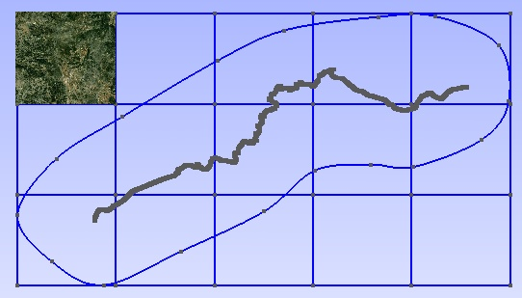
Using the new grid for simplifying texture mapping
If you use the lines of the new grid for splitting the non-driveable zone, may be you can then map the textures easily. So now you can decide to change the non-driveable zone.

Script simplificar now creates a separate .ply file for each surface belonging to the non-driveable zone, so they can be easily simplified. All the files on folder salida\nc_splitted should be processed with MeshLab, for simplifying or just to remove unreferenced vertex. When you have processed all of them, open s4_terrain\salida\nc_splitted\*.ply with MeshLab (you can open all in the same operation)
View-> Show Layer Dialog
Then Filters->Layer and ... -> Flatten visible layers. This combines all the grid cell's meshes. Save result as salida\n.ply

NOTE: add_dat_to_geo also creates a list of all the background images, with the format needed by BTB. It is called s1_mesh\list_bi.txt. It must be inserted by hand inside the Venue.xml (really easy to replace the empty list of background images in the 3rd line of this file).
Images should be named sat_X-Y.dds and should be located inside
My Project\XPacks\Common\Textures
(My project is your project’s BTB folder)

procesar_elementstxt_mt can automatically use the background images for the non-driveable zone, if the terrain is splitted using a grid of the same size as that used to create list_bi.txt.

For example:
procesar_elementstxt_mt(10,5,0) splits the terrain using 10x5 grid, but does NOT map background images to terrain zones. Inserting list_bi.txt and copying the images to Common\Textures folder will add the background images, but they will not be linked to the terrain.

procesar_elementstxt_mt(10,5,1) splits the terrain using 10x5 grid, using background images for blending in terrain zones. Before opening the Venue.xml It is mandatory inserting list_bi.txt into the Venue.xml and copying the images to Common\Textures folder. Otherwise BTB will refuse to open your project.

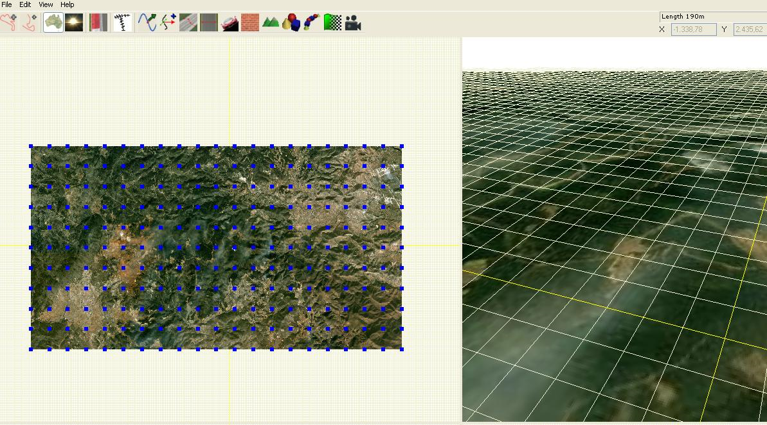

Example list_bi.txt
<BackgroundImages count="50">
<BackgroundImage>
<Path>Common\Textures\sat_1-1.dds</Path>
<Plane>
<Position x="-11232.375390" y="-0.5" z="5636.028398" />
<Scale x="2100.341106" y="1" z="-2311.287859" />
<Rotation x="0" y="0" z="0" />
</Plane>
</BackgroundImage>
<BackgroundImage>
<Path>Common\Textures\sat_1-2.dds</Path>
<Plane>
<Position x="-11232.375390" y="-0.5" z="3324.740539" />
<Scale x="2100.341106" y="1" z="-2311.287859" />
<Rotation x="0" y="0" z="0" />
</Plane>
</BackgroundImage>
etc.
</BackgroundImages>

